

**TUNKU ABDUL RAHMAN UNIVERSITY COLLEGE**

FACULTY OF COMPUTING AND INFORMATION TECHNOLOGY

BAIT2133 WEB ENGINEERING

PRACTICAL 8

**Assignment Progress:**

1. Create Hypertext Structure Model for your assignment.

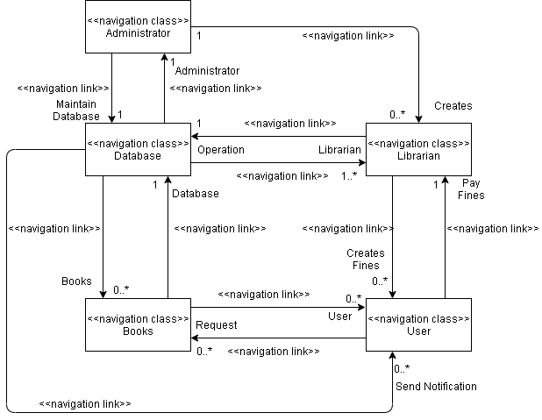

1. Create Hypertext Access Model for your assignment.

1. Review these models and perform necessary amendments/corrections.

This Hypertext's can present misleading information. This models also no credibility for the original author can be seen and information may be unreliable.